Healthcare from DW’s perspective

Using ORACLE

**Healthcare Organization, & its business environment**

The Sultanate's primary organization in charge of overseeing, coordinating, and providing for the health sector is the Ministry of Health. The Ministry of Health is the primary government organization that offers Oman's citizens curative care. It manages health facilities and hospitals at the municipal, regional, sub-regional, and national levels, all of which are connected by a referral network. MOH is needed to make sure that the health sector develops generally with respect to important social areas. According to this function, the MOH oversees overseeing appropriate coordination and serves as the main designer of the health system. It creates programs and policies for the healthcare industry. It carries out these in cooperation with all other relevant ministries, government-run health service organizations, and the private sector. The MOH also urges all other governmental systems to avoid enacting laws that could have a negative impact on public health and to instead support the health sector

Key aspects characterize the unique business environment in which hospitals function in Oman. Through the Ministry of Health, public financing and strict regulation play a pivotal role played by the government. Given the cultural diversity of the country's population, which is made up of both native-born citizens and foreigners, a broad range of healthcare services are required. Oman aggressively encourages medical tourism, drawing in patients from surrounding nations, which complicates the provision of healthcare services. Significant amounts of healthcare data are also produced by technical developments like telemedicine and Electronic Health Records (EHR).

**Potential benefits**

There are several benefits of integrating a Data Warehouse (DW) into Oman's hospital healthcare system. The DW, which serves as a consolidated repository, combines information from several sources, such as administrative records, financial databases, and Electronic Health Record (EHR) systems. By improving data availability, this consolidation enables hospitals to make well-informed decisions that will maximize patient care. Additionally, the DW is essential to enhancing analytics and reporting, giving hospitals important information about patient outcomes, resource allocation, and operational effectiveness. In keeping with the hospital's goals of providing excellent care at the lowest possible cost, the DW encourages efficient use of resources and cost savings. Enforcing strict access restrictions, encryption techniques, and adherence to Omani healthcare standards makes the DW a robust solution for ensuring healthcare data security and regulatory compliance. By protecting patient data, this fosters trust in the healthcare system's adherence to privacy laws and other regulations. Real-time monitoring, enabled by the DW, allows hospitals to optimize resource consumption and make treatment decisions in a timely manner. Both patient care and operational efficiency are enhanced by this. By using predictive analytics based on historical data, hospitals can improve patient care quality, increase overall operational effectiveness, and plan for the future. In addition to enhancing data management, a DW helps Oman achieve its overarching goals of delivering excellent, safe, and efficient healthcare services.

**Data warehouse system user**

Different user categories utilize the database to carry out specific tasks and roles:

|  |  |  |
| --- | --- | --- |
| Database user | Usage | Access level |
| Administrators | 1. Set up and keep up the data warehouse. 2. Control access rights and user accounts. 3. Maintain integrity and security of the system. | complete access to all configurations and data on the system. |
| Healthcare IT Staff | 1. Diagnose and fix technical problems. 2. Carry out maintenance and updates on the system. 3. Assure the data warehouse's general functionality and health. | complete access to system-related settings and technical configurations. |
| Doctors and Clinicians | 1. Access medication and doctor order data specific to a patient. 2. Patient records should be reviewed and updated as needed. 3. Make use of data when making clinical decisions. | Access to patient-specific data, both read and write.  restricted access to compiled or streamlined data for more thorough examination. |
| Pharmacists | 1. Control the dispensing and orders of medications. 2. Track prescription drug usage patterns. 3. Verify adherence to prescription regimens. | Access to medication order data, both reading and writing.  restricted access to data specific to physicians. |
| Finance and Billing Staff | 1. Access and examine billing information about prescription drugs and doctor orders. 2. Produce financial summaries. 3. Make that billing procedures are accurate. | Read access to financial and billing information. |
| Data Analysts | 1. Compile and produce reports based on medication and doctor order information. 2. Write and run queries for datasets. 3. Extrapolate significant insights to aid in decision-making. | 1. Read access to pertinent views and tables of data. 2. Just a restricted write access to create temporary views or tables. |

**Dimensional Model** 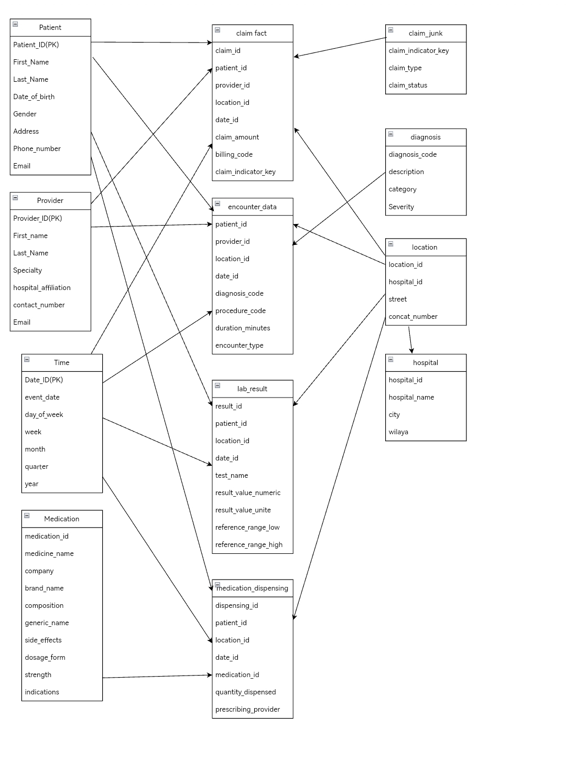

**Physical Design**

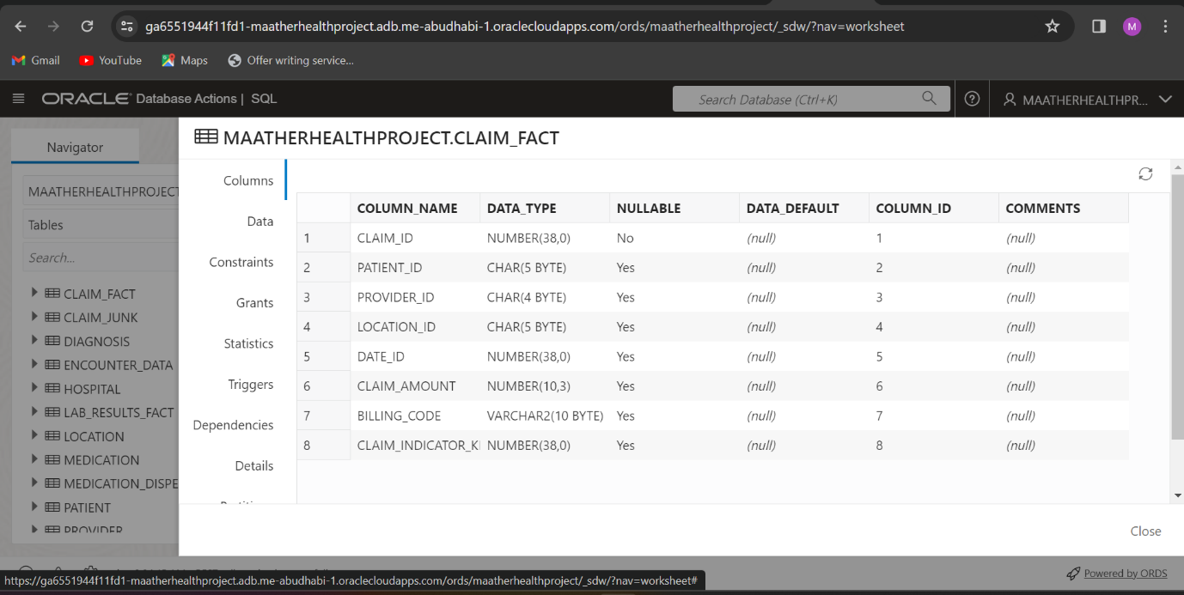

**Connection of Tables**

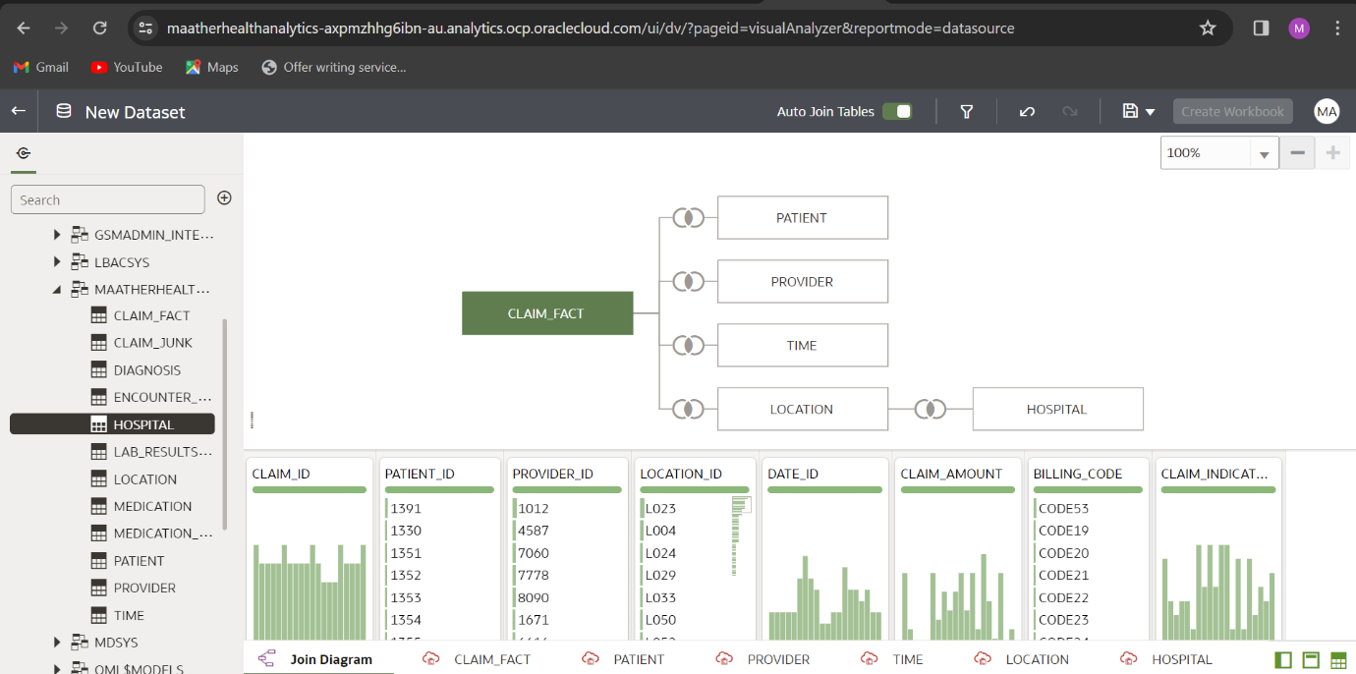

**Analytics**

**SQL Commands:**

WITH ClaimSummary AS (

    SELECT

        CLAIM_FACT.claim_id,

        CLAIM_FACT.patient_id,

        CLAIM_JUNK.claim_type,

        TO_CHAR(CLAIM_FACT.claim_amount, '9,999,999,999') AS ToCharClaimAmount,

        RANK() OVER (PARTITION BY CLAIM_FACT.patient_id ORDER BY CLAIM_FACT.claim_amount DESC) AS PatientClaimRanked

    FROM

        CLAIM_FACT, PATIENT, CLAIM_JUNK

    WHERE

        CLAIM_FACT.patient_id = PATIENT.patient_id AND

        CLAIM_FACT.Claim_Indicator_key = CLAIM_JUNK.Claim_Indicator_key

)

SELECT

    claim_id,

    patient_id,

    claim_type,

    ToCharClaimAmount,

    PatientClaimRanked

FROM

    ClaimSummary;

This SQL query analyzes data from the CLAIM_FACT table, joined with details from the PATIENT and CLAIM_JUNK tables, using the With function (table called ClaimSummary). It formats the claim amount, picks particular columns, and determines the rank of claims for every patient based on the claim amount. In order to provide a succinct summary of claim information, patient details, claim types, formatted claim amounts, and the corresponding ranks, the final SELECT statement extracts pertinent columns from the ClaimSummary.

CLAIM_ID PATIENT_ID CLAIM_TYPE TOCHARCLAIMAMOUNT PATIENTCLAIMRANKED

-------- ---------- ---------- ----------------- ------------------

1 1236 Medical 121 1

2 1241 Dental 90 1

3 1242 Vision 151 1

4 1243 Medical 200 1

5 1244 Vision 81 1

6 1245 Dental 110 1

7 1256 Medical 156 1

8 1311 Vision 135 1

9 1312 Dental 180 1

10 1321 Medical 70 1

11 1322 Vision 106 1

12 1323 Dental 126 1

13 1324 Medical 95 1

14 1325 Vision 146 1

15 1326 Dental 166 1

16 1327 Orthopedic 116 1

17 1328 Emergency 156 1

18 1329 Dental 136 1

19 1330 Medical 181 1

94 1330 Medical 181 1

20 1351 Vision 70 1

95 1351 Vision 70 1

21 1352 Orthopedic 106 1

96 1352 Orthopedic 106 1

22 1353 Emergency 126 1

97 1353 Emergency 126 1

23 1354 Medical 96 1

98 1354 Medical 96 1

24 1355 Dental 146 1

99 1355 Dental 146 1

25 1357 Vision 166 1

100 1357 Vision 166 1

26 1358 Orthopedic 116 1

101 1358 Orthopedic 116 1

27 1361 Emergency 156 1

102 1361 Emergency 156 1

28 1362 Medical 136 1

103 1362 Medical 136 1

29 1363 Dental 181 1

104 1363 Dental 181 1

30 1364 Vision 70 1

105 1364 Vision 70 1

31 1365 Orthopedic 126 1

32 1367 Emergency 95 1

33 1368 Medical 156 1

34 1369 Dental 205 1

35 1371 Vision 86 1

36 1372 Orthopedic 115 1

37 1373 Emergency 161 1

38 1374 Medical 140 1

39 1375 Dental 185 1

40 1376 Vision 75 1

41 1377 Orthopedic 111 1

42 1378 Emergency 131 1

43 1379 Medical 100 1

44 1381 Dental 151 1

45 1382 Vision 171 1

85 1382 Vision 171 1

46 1383 Orthopedic 121 1

86 1383 Orthopedic 121 1

47 1384 Emergency 161 1

87 1384 Emergency 161 1

48 1385 Medical 141 1

88 1385 Medical 141 1

89 1386 Dental 186 1

49 1386 Dental 186 1

90 1387 Vision 75 1

50 1387 Vision 75 1

91 1388 Medical 121 1

51 1388 Medical 121 1

52 1390 Medical 90 1

92 1390 Medical 90 1

84 1391 Dental 151 1

93 1391 Dental 151 1

53 1391 Dental 151 1

54 1392 Medical 200 1

55 1393 Vision 81 1

56 1394 Orthopedic 110 1

57 1395 Emergency 156 1

83 1396 Medical 135 1

58 1396 Medical 135 1

59 1397 Medical 180 1

60 1398 Medical 70 1

61 1399 Dental 106 1

62 1400 Dental 21 1

63 1401 Dental 21 1

64 1402 Emergency 21 1

66 1404 Medical 21 1

82 1404 Medical 21 1

67 1418 Emergency 34 1

68 1419 Dental 22 1

70 1420 Vision 90 1

71 1421 Vision 84 1

81 1422 Dental 37 1

72 1422 Dental 37 1

73 1423 Emergency 92 1

74 1424 Medical 63 1

76 1426 Orthopedic 84 1

77 1428 Orthopedic 92 1

78 1429 Medical 26 1

79 1430 Dental 27 1

80 1431 Emergency 26 1

Elapsed: 00:00:00.015

102 rows selected.

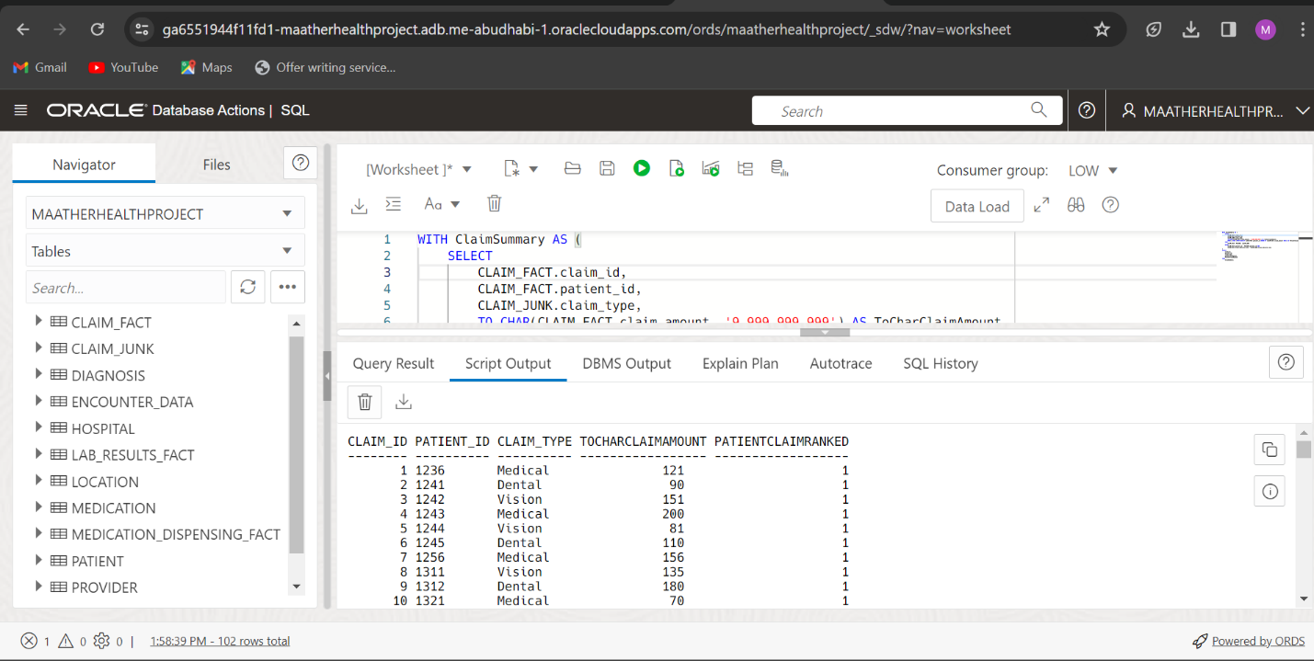

SELECT

    CLAIM_FACT.claim_id,

    CLAIM_FACT.patient_id,

    CLAIM_JUNK.claim_type,

    TO_CHAR(CLAIM_FACT.claim_amount, '9,999,999,999') AS ToCharClaimAmount,

    RANK() OVER (PARTITION BY CLAIM_FACT.patient_id ORDER BY CLAIM_FACT.claim_amount DESC) AS PatientClaimRanked

FROM

    CLAIM_FACT,

    PATIENT,

    CLAIM_JUNK

WHERE

    CLAIM_FACT.patient_id = PATIENT.patient_id

    AND CLAIM_FACT.Claim_Indicator_key = CLAIM_JUNK.Claim_Indicator_key

FETCH FIRST 10 ROWS ONLY;

Data from the CLAIM_FACT, PATIENT, and CLAIM_JUNK tables are retrieved using this SQL query. Certain columns, including claim_id, patient_id, and claim_type, are selected. The claim_amount column is formatted using the TO_CHAR function to display in a particular numeric format. Each row is given a rank using the RANK() window function, which is dependent upon the claim_amount's descending order within each partition that is defined by the patient_id. To restrict the result set to the first 10 rows, the query contains a FETCH FIRST 10 ROWS ONLY clause. For the top ten patients with the highest claim amounts, the query yields an overall summary of claim data.

CLAIM_ID PATIENT_ID CLAIM_TYPE TOCHARCLAIMAMOUNT PATIENTCLAIMRANKED

-------- ---------- ---------- ----------------- ------------------

1 1236 Medical 121 1

2 1241 Dental 90 1

3 1242 Vision 151 1

4 1243 Medical 200 1

5 1244 Vision 81 1

6 1245 Dental 110 1

7 1256 Medical 156 1

8 1311 Vision 135 1

9 1312 Dental 180 1

10 1321 Medical 70 1

Elapsed: 00:00:00.011

10 rows selected.

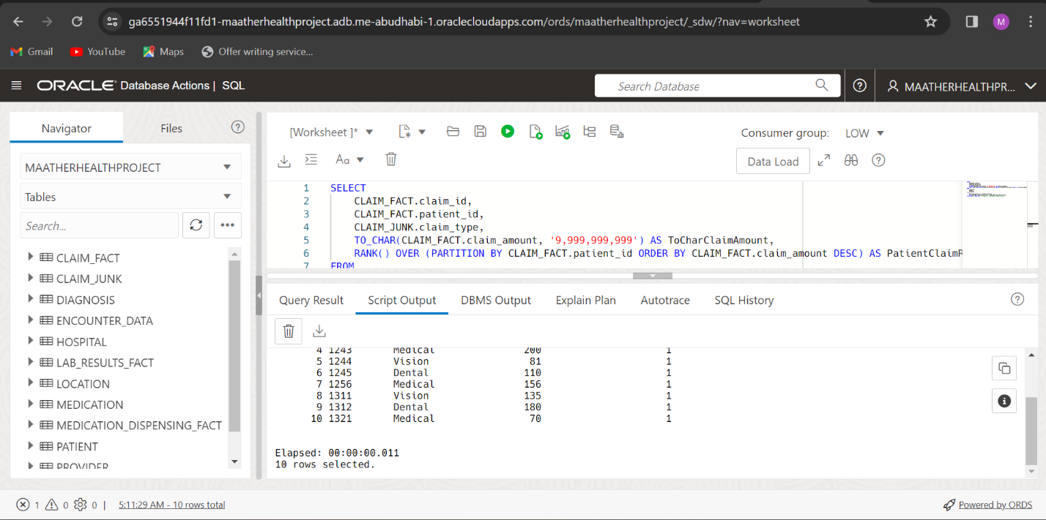

SELECT

    Claim_fact.claim_id,

    Patient.patient_id,

    Claim_junk.claim_type,

    TO_CHAR(MAX(Claim_fact.claim_amount), '9,999,999,999') AS ToCharClaimAmount,

    RANK() OVER (PARTITION BY Patient.patient_id ORDER BY MAX(Claim_fact.claim_amount) DESC) AS PatientClaimRanked

FROM

    CLAIM_FACT, PATIENT, CLAIM_JUNK, LOCATION

WHERE

    CLAIM_FACT.patient_id = Patient.patient_id

    AND CLAIM_FACT.Claim_Indicator_key = CLAIM_JUNK.Claim_Indicator_key

    AND CLAIM_FACT.location_id = LOCATION.location_id

GROUP BY

    Claim_fact.claim_id,

    Patient.patient_id,

    Claim_junk.claim_type;

Information is retrieved from the CLAIM_FACT, PATIENT, CLAIM_JUNK, and LOCATION tables using this SQL query. Certain columns, including claim_id, patient_id, and claim_type, are selected. The maximum claim_amount for each patient is formatted with a particular numeric format using the TO_CHAR function. A rank is assigned to each patient using the RANK() window function, which is based on the maximum claim_amount sorted in descending order. The results are grouped by patient_id, claim_type, and claim_id in the GROUP BY clause. The patient_id in CLAIM_FACT and the patient_id in PATIENT, as well as the Claim_Indicator_key in CLAIM_FACT and CLAIM_JUNK, should match, according to the WHERE clause's definition of conditions for joining tables. It also contains a condition regarding the location_id. A summary of claim data sorted by patient is given by this query, along with the maximum claim amount and a ranking of each patient according to their maximum claim amount.

CLAIM_ID PATIENT_ID CLAIM_TYPE TOCHARCLAIMAMOUNT PATIENTCLAIMRANKED

-------- ---------- ---------- ----------------- ------------------

1 1236 Medical 121 1

2 1241 Dental 90 1

3 1242 Vision 151 1

4 1243 Medical 200 1

5 1244 Vision 81 1

6 1245 Dental 110 1

7 1256 Medical 156 1

8 1311 Vision 135 1

9 1312 Dental 180 1

10 1321 Medical 70 1

11 1322 Vision 106 1

12 1323 Dental 126 1

13 1324 Medical 95 1

14 1325 Vision 146 1

15 1326 Dental 166 1

16 1327 Orthopedic 116 1

17 1328 Emergency 156 1

18 1329 Dental 136 1

94 1330 Medical 181 1

19 1330 Medical 181 1

20 1351 Vision 70 1

95 1351 Vision 70 1

96 1352 Orthopedic 106 1

21 1352 Orthopedic 106 1

22 1353 Emergency 126 1

97 1353 Emergency 126 1

98 1354 Medical 96 1

23 1354 Medical 96 1

24 1355 Dental 146 1

99 1355 Dental 146 1

25 1357 Vision 166 1

100 1357 Vision 166 1

101 1358 Orthopedic 116 1

26 1358 Orthopedic 116 1

27 1361 Emergency 156 1

102 1361 Emergency 156 1

28 1362 Medical 136 1

103 1362 Medical 136 1

29 1363 Dental 181 1

104 1363 Dental 181 1

105 1364 Vision 70 1

30 1364 Vision 70 1

31 1365 Orthopedic 126 1

32 1367 Emergency 95 1

33 1368 Medical 156 1

34 1369 Dental 205 1

35 1371 Vision 86 1

36 1372 Orthopedic 115 1

37 1373 Emergency 161 1

38 1374 Medical 140 1

39 1375 Dental 185 1

40 1376 Vision 75 1

41 1377 Orthopedic 111 1

42 1378 Emergency 131 1

43 1379 Medical 100 1

44 1381 Dental 151 1

45 1382 Vision 171 1

85 1382 Vision 171 1

46 1383 Orthopedic 121 1

86 1383 Orthopedic 121 1

47 1384 Emergency 161 1

87 1384 Emergency 161 1

48 1385 Medical 141 1

88 1385 Medical 141 1

89 1386 Dental 186 1

49 1386 Dental 186 1

90 1387 Vision 75 1

50 1387 Vision 75 1

91 1388 Medical 121 1

51 1388 Medical 121 1

92 1390 Medical 90 1

52 1390 Medical 90 1

53 1391 Dental 151 1

84 1391 Dental 151 1

93 1391 Dental 151 1

54 1392 Medical 200 1

55 1393 Vision 81 1

56 1394 Orthopedic 110 1

57 1395 Emergency 156 1

58 1396 Medical 135 1

83 1396 Medical 135 1

59 1397 Medical 180 1

60 1398 Medical 70 1

61 1399 Dental 106 1

62 1400 Dental 21 1

63 1401 Dental 21 1

64 1402 Emergency 21 1

66 1404 Medical 21 1

82 1404 Medical 21 1

67 1418 Emergency 34 1

68 1419 Dental 22 1

70 1420 Vision 90 1

71 1421 Vision 84 1

81 1422 Dental 37 1

72 1422 Dental 37 1

73 1423 Emergency 92 1

74 1424 Medical 63 1

76 1426 Orthopedic 84 1

77 1428 Orthopedic 92 1

78 1429 Medical 26 1

79 1430 Dental 27 1

80 1431 Emergency 26 1

Elapsed: 00:00:00.017

102 rows selected.

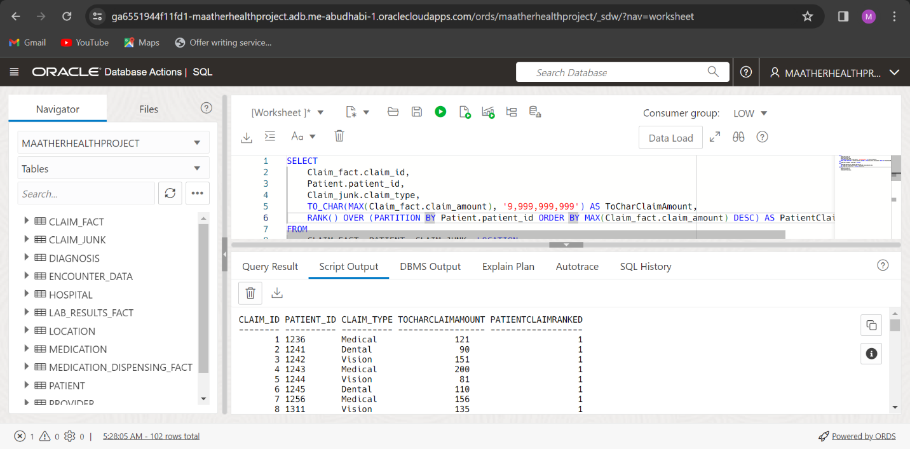

I plan to successfully communicate two important insights to users with this visualization. The total amount of medication prescribed for every patient is displayed as a bar chart on the right. To improve readability, a reference line indicates the mean, and conditional formatting identifies patients according to the amount they were given: patients with a total of more than 29 are underlined in red, patients with a total of less than 29 are underlined in blue, and patients with a total of equal to 29 are underlined in brown. Patient privacy is protected by using patient IDs for readability. The graph illustrates that patients on the left typically have more than 29 dispensed, whereas patients on the right typically have less. Using this visualization, decision-makers can investigate the root causes of patients' higher medication dispensation rates and give priority attention to them. A language narrative on the left offers a written synopsis, providing a substitute for individuals who might find it difficult to read the graph and guaranteeing a thorough comprehension of the message being communicated.

I created two analytical graphs on this canvas. The count of dispensing_id is shown as a line chart on the right, which includes a calculated field that pulls the year from the date. The dispensing_id trend over several years is clearly depicted by the Trend line, which uses a linear method and color coding. The graph most notably shows a spike in dispensing_id in 2021. The 2020 trend starts off at a peak and then progressively gets worse. Furthermore, the graph projects dispensing_id through 2040. Another Line chart on the left looks at a different angle, analyzing the relationship between the name of the medication, the quantity dispensed, and the year. To improve readability, different colors are used to represent different medicine names. The graph indicates that the medication known as "HeartWell" saw the greatest amount dispensed in 2020—60—and then decreased to 19 in 2022. By examining the amount prescribed for each medication, this chart helps decision-makers—especially those in the medical field—gain valuable knowledge about common illnesses and enhances general health and wellness.